**MUNEEB IQBAL**

**Sp22-bcs-030**

**Vp assignment**

**(theory)**

**DLL File:**

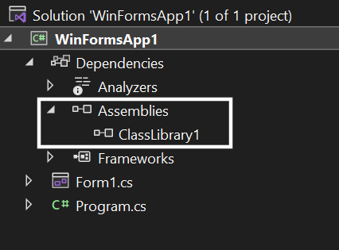

using ClassLibrary1;

namespace WinFormsApp1

{

public partial class Form1 : Form

{

MathFUnction m;

public Form1()

{

InitializeComponent();

m = new MathFUnction();

}

private void button1_Click(object sender, EventArgs e)

{

double x = Convert.ToDouble(this.textBox1.Text);

double y = Convert.ToDouble(this.textBox2.Text);

MessageBox.Show(m.Add(x, y).ToString());

}

private void button2_Click(object sender, EventArgs e)

{

double x = Convert.ToDouble(this.textBox1.Text);

double y = Convert.ToDouble(this.textBox2.Text);

MessageBox.Show(m.Sub(x, y).ToString());

}

private void button3_Click(object sender, EventArgs e)

{

double x = Convert.ToDouble(this.textBox1.Text);

double y = Convert.ToDouble(this.textBox2.Text);

MessageBox.Show(m.Mul(x, y).ToString());

}

private void button4_Click(object sender, EventArgs e)

{

double x = Convert.ToDouble(this.textBox1.Text);

MessageBox.Show(m.Factorial(x).ToString());

}

}

}

**DDL File Code:**

namespace ClassLibrary1

{

public class MathFUnction

{

public double Add(double x, double y)

{

return x + y;

}

public double Sub(double x, double y)

{ return x - y; }

public double Mul(double x, double y) { return x * y; }

public double Factorial(double x)

{

double factorial = 1;

for (int i = 1; i <= x; i++)

{

factorial = factorial* i;

}

return factorial;

}

}

}

**Output:**

